From: https://davidstockmanscontracorner.com/the-lost-decades-2000-2020-part-2/

The Lost Decades, 2000-2020, Part 2
By David Stockman. Posted On Tuesday, December 31st, 2019
Talk about whistling loudly past the very gates of the financial graveyard!
Alas, what we have here is a Wall Street which refuses to get its head right. That's because after two decades of monetary, fiscal and financial folly honest price discovery is dead as a doornail and collective reasoning about anything except the next dose of monetary heroin from the central banks has disappeared entirely.
So it's perhaps a fitting last hurrah that the S&P 500 was up 30% and the NASDAQ 100 up 40% during the final year of a two decade-stretch which will go down as the birthing time of the greatest calamity in economic history.
Presently we will get to the vast dangers of the current speculative mania and to the overwhelming evidence that economic growth of the historic variety has been virtually snuffed out. But here on the last day of the decade, it is well worth highlighting the soon to be marauding elephant in the room: Debt--- both the public and private kind of it.
As to the former, it's hard to imagine a more feckless two decades. On December 31, 1999, the public debt stood at $5.6 trillion, which was the work of 212 years of the Republic's history including 42 presidents and 106 Congresses.
By contrast, three presidents and 10 congress during the 21st century to date have re-written the history books. Not only has the public debt soared to $23.1 trillion, reflecting an 8.3% per annum growth rate or more than double the nominal GDP gain of 3.9% per year, but the forward momentum and direction has also reversed dramatically and disastrously.
To wit, there is now baked-into-the-cake more than $43 trillion of public debt well before the end of the 2020s. So at decade's end the question urgently recurs: How did America get from $5.6 trillion of public debt to $43 trillion in what will be less than three decades?
At the turn of the century, of course, that fiscal calamity was not even remotely on the radar screen. The Federal budget was actually generating a $235 billion or 2.4% of GDP surplus (FY 2000), but more importantly, the CBO baseline forecasts for the Federal budget actually projected that the public debt would be completely retired by 20o9!
Nowadays the very idea of a debt-free nation sounds utterly bizarre, so for want of doubt here is the evidence. As the new century opened in January 2000, the Clinton administration grandly announced that the nation would be debt-free by the end of the decade:
Today, President Clinton will announce that the United States is on course to eliminate its public debt within the next decade. The Administration also announced that we are projected to pay down $237 billion in debt in 2001. Due in part to a strong economy and the President's commitment to fiscal discipline, the federal fiscal condition has improved for an unprecedented nine consecutive years.
Based upon today's new economic and budget projections for the coming 10 years from the Office of Management and Budget (OMB). The United States can be debt-free this decade. By dedicating the entire budget surplus to debt reduction, The United States can eliminate its publicly held debt by FY 2009.
A Democrat president. A strong economy. A commitment to fiscal discipline.
That sounds way too good to be true---and, of course, it was!
As it happened, the purported debt-free condition projected for the end of the decade was owing to two crucial assumptions. Namely, that Congress wouldn't alter current law (i.e. taxes and spending in place as of the year 2000) and spend the surplus, and that there would be no recession ever again.
Under these happy assumptions, Uncle Sam would have generated cumulative surpluses of $5.6 trillion between FY 2002 and FY 2011.
That would have been enough to pay down the $5.6 trillion debt, and would also have been a prudent fiscal stepping stone to the 2020s and beyond when the Welfare State was positioned to balloon under the weight of 100 million retirees in the decades after 2020.
Needless to say, the bipartisan duopoly on both ends of Pennsylvania Avenue could not stop looking a gift horse in the mouth. So doing, they appropriated the impending surplus to more spending on
- pork barrels at home and
- Forever Wars abroad
with reckless abandon.
They also enacted serial tax cuts that were to be paid for by borrowing, not off-setting spending cuts. And they did so even as the Keynesian stimulators at the Fed generated a truly lunatic housing and credit bubble and the subsequent financial crash that sent the US economy into the drink.
So when the smoked had cleared after
- the Bush tax cuts,
- the Obama shovel ready stimulus,
- the Forever Wars and
- the Fed's new style bursting-bubble induced recession,
the cumulative budget outcome for the 10 years was of the very opposite sign.
That is, during FY 2002-2011, Washington generated cumulative deficits of $6.1 trillion, thereby turning the prospective debt-free nation into one burdened with a public debt well into the double-digit trillions.
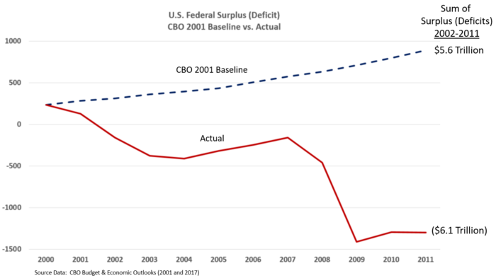
Yet that was only the preliminaries. As shown in the chart below, had the policies in place at the turn of the century actually been adhered to for the next three decades, the $5.6 trillion surplus shown above what have cumulated to $15 trillion by 2028.
That is, after paying off the turn of the century public debt, America would have had in place a $10 trillion rainy day fund to help absorb the demographic/retirement time-bomb that was undeniably heading down the pike.
Needless to say, the road not taking has turned into a fiscal nightmare. As John Mauldin recently noted,
If your average picture is worth a thousand words, the one below is worth many more.
It comes from former Treasury economist Ernie Tedeschi. Ernie pointed out that what seemed to be reasonable assumptions back at the time would have added up to a $15 trillion cumulative budget surplus through 2028.
That would have been nice, and probably allowed Greenspan to be right about paying off the debt. It didn’t happen. Instead, Ernie now foresees a $28 trillion cumulative deficit.
In other words, over a 27-year period the assumptions will have been about $43 trillion off.....
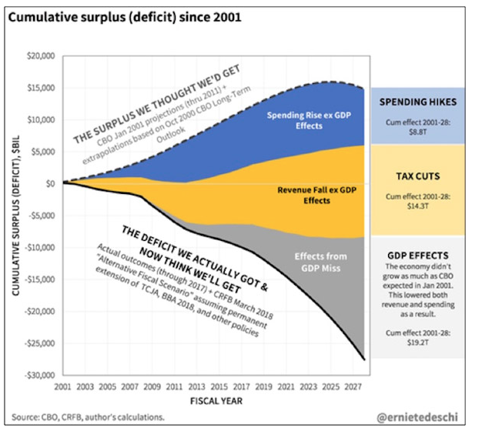
This stunning chart also makes clear how what was a $5.6 trillion public debt in 2000 and heading for zero by the 2010s turned into what will be a public debt north of $40 trillion by the end of the decade which incepts tomorrow, and far, far more to go in the decades beyond.
To wit, by 2018 (when the chart was published) Washington had added nearly $9 trillion to an already bloated spending baseline over that 27 year period. And, then, after the bipartisan spenders have gorged themselves with wars, waste and free stuff, the GOP tax cutters took their turn at bat.
So doing, they made exactly zero effort to follow the norm of fiscal rectitude that the great Dwight Eisenhower had established back in the 1950s, when he inherited the high taxes which had been instituted by FDR and Truman.
To wit, Ike properly said that Republican governments must earn the right to confer tax cuts on an appreciative public by first cutting spending deeply and balancing the budget. Ike properly believed that you did no one a favor---and most especially future generations---by simply borrowing money to pay for tax cuts.
Needless to say, by the turn of the century, Ike's fiscal wisdom had been supplanted by the nostrums of two great GOP charlatans of the 2oth century----Art Laffer and Newt Gingrich.
The former mendaciously insisted that tax cuts pay for themselves, which is not remotely possible----even mathematically---in an economy that starts with only a 17-18% of GDP Federal tax burden.
And Gingrich argued that Republicans should not be tax collectors for the Welfare State, but shouldn't try to shrink social security, Medicare and the other big entitlements without bipartisan support, either. Since the latter was never going to happen, the Gingrich GOP ended up giving hypocrisy a bad name and fiscal irresponsibility a whole new definition.
For the last three decades they [Republicans?] have ballooned the Warfare State, never voted once for a material retrenchment of the Welfare State and have frequently joined the bipartisan fray adding to it. At the same time, they have ceaselessly cut taxes whenever the opportunity arose---even as they blamed the Dems for the resulting mushrooming public debt.
Accordingly, Federal taxes have been cut by a cumulative $14.4 trillion over that 27-year period with nary a dime of honest, sustained spending cuts to off-set the revenue drain.
Finally, thanks to mushrooming public and private debts which have grown from $27 trillion in the year 2000 to $74 trillion at present, and the recession-inducing serial financial bubbles fueled by the Fed, the economy has performed the very opposite of Rosy Scenario.
Owing to two recession already this century and the weakest recovery in history after the financial crisis, real GDP has grown by only 1.9% during the last 19 years and just 1.6% per annum since the pre-crisis peak in Q4 2007. Those tepid gains are well less than half half the 4.1% per annum growth posted during the 19-year heyday of American prosperity between 1954 and 1973.
As a result, another $19.2 trillion of red ink was added to the CBO projections and budget path which was in place at the turn of the century.
In earlier times we would have said that only Washington can make a $43 trillion mistake and live to tell about it. But that is no longer the case in the present era of Keynesian central banking.
Owing to the falsification of interest rates and financial asset prices, the private sector has gorged on debt, as well. Thus between the end of 1999 and the present,
- Household debt has risen from $6.6 trillion to $16.0 trillion;
- Total business debt has gone from $6.0 trillion to $16.0 trillion; and
- Financial sector debt has mushroomed from $7.7 trillion to $16.6 trillion.
In all, domestic non-government debt has rising from $20.4 trillion to $48.6 trillion and from an already high (by historic standards) 207% of GDP in 2000 to 225% of GDP at present.
In Part 3 we will review how this debt explosion has ground the growth potential right out of the US economy at the very worst time imaginable. That is, at the onset of the Turbulent Twenties when the Baby Boom driven Welfare State and the Washington Warfare State is pushing the nation's fiscal accounts to the brink
Nevertheless, the truth is the Lost Decades of this century to date have produced a total public and private debt mountain that was utterly unimaginable when the 21st century opened exactly 20 years ago to the date.
Back then, total debt stood at $26.8 trillion and a towering 270% of GDP. Today it is off the charts. The decade will close with total debt of $74 trillion---a 345% of GDP albatross at the very time when America needs high economic growth like never before.
That this is aberrant and unsustainable is evident in the basic math. Since December 1999, GDP is up by $11 trillion while total debt is up by $47 trillion. At a clip of $4.27 of debt per dollar of GDP, you truly cannot borrow you way to prosperity!
Stated differently, since the turn of the century, national income should have been growing faster than total debt in order to provide cushion for the Baby Boom retirement tsunami.
Alas, the very opposite happened
